ACME Corporation
Case Study Workbook

The Transition into Project Management
Development Workshop

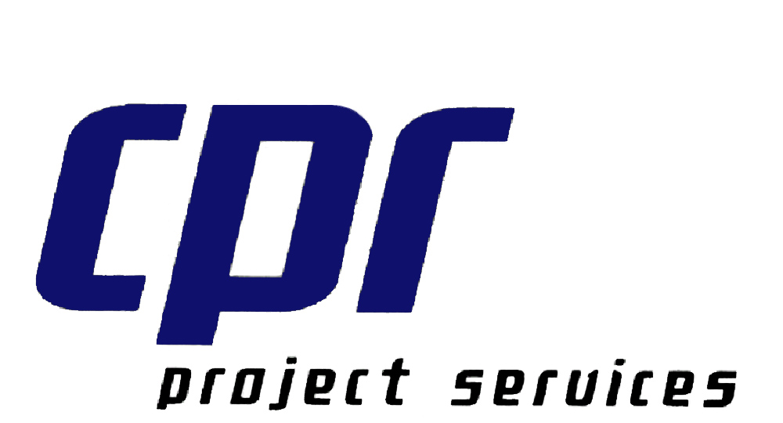 | 

Table of Contents:
Project Background: ACME Corporation’s Intranet/Website 3
Getting Started Exercise 5
Stakeholders and Needs Assessment 5
Stakeholders and Needs Assessment (Suggested Answers) 6
Communications Planning 7
Communications Planning (Suggested Answers) 8
Project Initiation and Risk Exercise 9
Risk Assessment Survey 10
Risk Assessment Survey (Answers) 12
Project Charter 14
Stakeholders and Project Scope (Suggested Answers) 15
Project Charter Template 16
Project Charter (Example) 19
Project Planning Exercise 22
Work Breakdown Structure 22
Sample Work Breakdown Structures 23
ACME WBS (Possible Solution) 26
Network Diagram 27
Network Diagram (Solution) 28
Critical Path 29
Critical Path (Solution) 30
Gantt Chart 31
Project Execution Exercise 32
Win All That You Can! 32
Project Control Exercise 33
Managing the Project 33
Managing the Project (Possible Solutions) 34
Instructor Notes Error! Bookmark not defined.

Project Background: ACME Corporation’s Intranet/Website

Sponsor: ACME has just hired a COO from a Fortune 1000 company to develop a more systematic and structured corporate approach to business. In the recent past ACME grew by acquiring smaller companies, these days they no longer look to mergers and acquisitions for growth. ACME’s revenue per employee has been slipping ($105,000 to $100,000 in the past year) and the board of directors wants the new COO to turn things around.

The COO believes the company needs to improve its processes in order to continue on its growth path. As part of this effort, the COO wants to document formal policies and procedures, and make them available to everyone through a browser interface over a company intranet. The intranet would also contain other internal company information such as press releases and employee benefits. The COO is also interested in a central catalog of ACME products and services for internal sales staff use. The COO has determined the average employee is only productive 6 hours out of every 8-hour day. The corporate intranet would serve to make everyone much more productive.

Conflict: A cadre of techies have lots of great ideas for applying the latest web technologies in ways the COO hasn’t imagined; marketing wants to use this project to replace ACME’s current website and turn it into an externally-accessible site for marketing information; the project managers see this as an opportunity to develop a portal for all ACME projects; managers don’t want to lose resources from billable work, so they want this project to be fast and cheap.

Organization: The Project Manager (PM) reports to a program manager who reports to a division VP with responsibility for both external and internal projects. The Division VP reports to the COO that has requested the project.

Culture: ACME started as two techies building PCs, installing commercial networks, and developing websites. Later, as it gained business through word-of-mouth, ACME became an ISP as well. ACME is a very entrepreneurial company that has grown to 250 employees. It has established a very solid reputation as a provider of PC’s and Web Access for the small office suite. An informal and inventive culture exists with each business unit working independently. Roles and responsibilities are fluid and ill defined. Current Web Sites are under featured and lack any degree of coordinated sophistication. To complicate matters most of the web-based procedures they have were acquired as part of a merger. They are all run as separate systems. The company’s founders have been struggling to move towards more systematized operations and better-defined structure; hiring a large-company COO is one step in the process. This project will test the blend of the two cultures. Many managers have grumbled saying they don’t have time to waste on silly reports, but the COO has firmly stated that things will be done by the book and done quickly.

Situation: Project startup. You are the PM. You have four programmers on your project team, but they are also slated for billable project work that could start any time.

Challenges:
- Stakeholder identification and communication
- Charter definition and coordination
- Scope definition, creep, and change
- Effort and schedule estimation
- Resource management
- Progress measurement
- Corrective action

Getting Started Exercise
Identify the stakeholders and their needs. Think about how this project's outcome will affect them and what they might be concerned about.

Stakeholders and Needs Assessment
Stakeholder | Needs

Stakeholders and Needs Assessment (Suggested Answers)
Stakeholder | Needs
Project Manager | Interested in managing the development of a corporate intranet successfully in terms of time, cost, quality and scope. Interested in balancing the needs of others and mitigating risks that might be encountered during the project.
ACME Employees | The employees will need to use the corporate intranet once it is developed to speed the required flow of timely and accurate corporate information. They need the intranet to be simple and easy to use. It must help solve a legitimate problem that they encounter in their normal duties at ACME.
Project Team  (Techies) | The team most responsible for developing the corporate intranet. They need to perform the technical work to accomplish the goals of the project. They have a need to contribute their talent and expertise on challenging and rewarding projects. ACME's technical community looks at this project as an opportunity to try out new technology and demonstrate their knowledge and creative talents
ACME COO | The COO wants to streamline the business processes in place at ACME. Future growth for the company will depend upon improved processes that will lead to higher productivity and corporate profits. He wants the company to perform better, faster and with higher employee output. This project is tightly aligned with this strategy. It is the responsibility of the COO to operationalize strategy.
ACME Board and Executive Team | They are interested in making strategic decisions, which will lead the company to higher profitability and growth. They want ACME to transition from a highly technical niche company into a larger well-managed company while maintaining the entrepreneurial culture that has made them successful.
Program Mgr. (your boss) | Your boss is interested in successfully managing a group of projects. This project is a highly visible project that must succeed but it must do so without hurting the outcomes of the other projects in the department. The intranet could also be helpful as a tool for integrating and managing these projects. The program manager is also responsible for the cost of a project, and expects your input when making decision about which changes to approve and which to deny.
ACME  Dept. VP's | Each department VP might see the intranet as a tool that can be specifically tailored to meet their department's needs. In talking with your boss, you learn that the sales force badly needs a product catalog to support sales staff members in the field. Their print media resources are not up to date. In short they don’t know the current product offerings. In addition to the employee benefit improvement, Human Resources wants to upgrade the current Employee Relations system, which is about the same size and used just as much. They feel that streamlining their business processes will reduce their costs. Be cause it changes often, Public Relations wants easy access to their content. They also want show the same videos they show at trade shows, they want to do this by linking to the streaming video web site of the video production house that is already under contract to ACME.
ACME Customers | ACME's customers want to deal with a top-notch company. Any project or improvement that allows ACME to better serve the customer will be well received. The customer will benefit from lower costs, higher quality, and faster response times.

Communications Planning
Begin the formulation of a communications plan that will respond to the needs of the stakeholders. Remember that project resources should only be expended on communicating information that contributes to success or where lack of communications could lead to failure.
Stakeholder | Information Needed | Type/Format | Frequency /  When Needed | Value of the Information

Communications Planning (Suggested Answers)
Stakeholder | Information Needed | Type/Format | Frequency /  When Needed | Value of the Information
Project Manager | Project Plan  Work status / Cr. Path  Risk items  Change requests  Earned value  Stakeholder Comm. | Formal Doc  Team Mtgs.  Team Mtgs.  Formal Doc.  Electronic  Formal Mtgs.  Informal Mtgs. | Ongoing  Weekly  Weekly/ As needed  As needed  Weekly  Depends on  Stakeholder | Fulfill project goals  Determine progress  Mitigate risks  Avoid Scope Creep  Control of the project  Depends on Stakeholder  (See below)
ACME Employees | Intranet Training Doc.  Product Availability  Access Information | Electronic Doc.  Email or Letter  Email, Letter and  Emp. Manual | Product Release  Product Release  Product Release | Access and How to Use  Availability  Access and How to Use
Project Team | Project Scope  Team Assignments  Technical Info.  Problem Info.  Change Requests | Formal Doc.  Formal Doc.  Various  Team Mtgs.  Formal Doc. | Startup & Changes  Sufficient lead time  As needed  As needed  As needed | What needs to be done.  What, when, who  Enables team to do the job  Overcome obstacles  Evaluate impact
ACME COO | Cost/Benefit Info.  Charter  Change Requests  Project Status  Project Costs, Sched.  Project Plan | Documentation  Formal Doc.  Formal Doc.  Formal Doc.  Formal Doc  Formal Doc. | Init. & Closeout  Initiation  Weekly  Weekly  Phase Changes  or when needed  Startup & Changes | Financial payoff  Scope and Risk  Approval mechanism  Control/Actions  Control/Actions  Time, Cost, Resource Mgt.
ACME Board and Executive Team | Cost/Benefit Info.  General Status | Formal Doc.  Formal Doc. | Init. & Closeout  Quarterly | Strategic Planning  Control/Strategic Actions
Program Mgr. (your boss) | Cost/Benefit Info.  Charter  Change Requests  Project Status  Project Costs, Sched.  Project Plan | Documentation  Formal Doc.  Formal Doc.  Formal Doc.  Formal Doc  Formal Doc. | Init. & Closeout  Initiation  Weekly  Weekly  Phase Changes  or when needed  Startup & Changes | Financial payoff  Scope and Authority  Approval mechanism  Control/Actions  Control/Actions  Time, Cost, Resource Mgt.
ACME  Dept. VP's | Cost/Benefit Info.  Charter  General Info.  Intranet Training Doc. | Documentation  Formal Doc.  Electronic Doc.  Email or Letter | Init. & Closeout  Initiation  Product Release  Product Release | Financial payoff Project  Scope and Impact  Planning and how  to take advantage of new  product.  Access and How to Use
ACME Customers | Highlight Info. | Press Release | Web site | Assurance of Sound Strategic Planning and Improved Operations.

Project Initiation and Risk Exercise

Prior to any significant amount of work being started on a new project, it must undergo a feasibility study to determine whether the benefits outweigh the costs of the project. The Chief Operating Officer (COO) has already performed this analysis believes the project will pay for itself in less than 2 years. The COO will accept any IT project with a payback period of 4 years or less.

The Sales Catalog and the Employee Benefits improvements are expected to increase productivity by 2%, which will result in an expected revenue increase of $500,000 per year. The COO has determined that project payback for this 6-month duration project will be approximately 13 months. The COO has set the budget split at 70% for the Sales catalog, 10% for HR and 5 % on PR. The rest of the budget has not been allocated.

As project manager, it is up to you to manage risks that might impact the success of the project. In developing a risk management plan for the project, it is often beneficial to run through a checklist or questionnaire that identifies the project's potential for success.

Rate the questions in the following survey (checklist) by your ability to say “Yes” to them. For example, a question might be: "Have all the regulations regarding the financial transactions been identified?”

Answer by your ability to say “Yes”: 1-no way, 2- some way, 3- half way, 4- a great way, 5- all the way.

If you haven’t even asked anyone about regulations, there is no way you would say ”Yes” to the question, so you answer 1: “no way”.

If you have a meeting set up for next week, with the compliance officer for loans, you may feel somewhat inclined to answer "Yes”, so you chose answer 2 or 3.

If you have a meeting set up for next week, with the compliance officer, the legal trade mark and service mark representatives, and the Advertising Department, you may feel strongly that you could answer yes to the question, but the meeting really hasn't happened yet, so you would answer 4.

If you have already had that meeting, and received an email from the compliant officer listing everybody's requirements from the meeting, then you could answer “Yes” emphatically, so 5: “all the way”.

Fill out the survey and discuss any potential problems that could affect the project's success. Not all questions may be applicable at this point in the project (initiation phase) but the survey will point out things that may need to be done before the project gets started. Answer the questions the best that you can with the information provided.

Create your own question for 2.5, we will discuss your question with the other teams.
Risk Assessment Survey
Key: Ability to say “Yes”: 1-no way, 2- some way, 3- half way, 4- great way, 5- all the way.
TBD: To be determined.
1-5/TBD
1. USER INVOLVEMENT
1.1 Have the right user(s) been identified for involvement?
1.2 Does the project involve the user(s) early and often?
1.3 Does the project allow good communications with users?
1.4 Does senior management make involvement easy?
1.5 Have the user(s) needs been identified?

2. EXECUTIVE MANAGEMENT SUPPORT
2.1 Does the project have the support of key executive(s)?
2.2 Does the key executive(s) have a stake in the outcome?
2.3 Does the project have a well-defined plan?
2.4 Does the project team have a stake?
2.5 (Create your own question)

3. CLEAR STATEMENT OF REQUIREMENTS
3.1 Does the project have a concise vision?
3.2 Has a functional cross-section analysis been carried out?
3.3 Has a risk assessment been carried out?
3.4 Has a business case been developed?
3.5 Have metrics, measurements and milestones to determine success
and/or completion of the project been defined?

4. PROPER PLANNING
4.1 Has a Concept statement been developed?
4.2 Has a requirements definition document been developed?
4.3 Have the right people been planned for?
(Are they available to work on the project?)
4.4 Have firm functional specifications been developed?
4.5 Does the project plan have attainable milestones?

5. REALISTIC EXPECTATIONS
5.1 Does the project have attainable specifications?
5.2 Are the desired features possible given budget and time constraints?
5.3 Does the project have small milestones?
5.4 Is change managed?
5.5 Is the project prototyped?

1-5/TBD
6. SMALLER PROJECT MILESTONES
6.1 Is the project management using the 80/20 rule?
(Focusing on the 20% of effort that results in 80% of the benefits).
6.2 Has a top-down design been developed?
6.3 Have time limits been set on project milestones?
6.4 Are prototyping tool(s) being used?
6.5 Are results measured and quantified?

7. COMPETENT STAFF
7.1 Have the required skills for the project been identified?
7.2 Have right mix of people been assigned or recruited to the project?
7.3 Has a continuous training program been developed?
7.4 Have appropriate incentives been provided to the project team?
7.5 Is the project team committed to seeing the project through?

8. PROJECT OWNERSHIP
8.1 Have the roles and responsibilities of each team member
been clearly defined?
8.2 Has an organization chart been developed?
8.3 Have the roles and responsibilities been communicated throughout
the corporation?
8.4 Do the incentives support project success?
8.5 Has commitment from key executives and users been obtained?

9. CLEAR VISION AND OBJECTIVES
9.1 Is the vision shared by all groups affected by the project?
9.2 Is the vision aligned with company goals?
9.3 Are the objectives achievable?
9.4 Are the objectives measurable?
9.5 Are the objectives regularly checked to ensure success?

10. HARD WORKING, FOCUSSED STAFF
10.1 Are the incentives tailored to the individuals’ needs?
10.2 Are the staff concentrating on quantifiable deliverables?
10.3 Does each member have part ownership?
10.4 Does the project team work well together?
10.5 Is confidence being built with attainable results and milestones?

Risk Assessment Survey (Answers)
1-5/TBD
1. USER INVOLVEMENT
1.1 Have the right user(s) been identified for involvement? 5
1.2 Does the project involve the user(s) early and often? 5
1.3 Does the project allow good communications with users? 5
1.4 Does senior management make involvement easy? 5
1.5 Have the user(s) needs been identified? 5

2. EXECUTIVE MANAGEMENT SUPPORT
2.1 Does the project have the support of key executive(s)? 5
2.2 Does the key executive(s) have a stake in the outcome? 5
2.3 Does the project have a well-defined plan? 1
2.4 Does the project team have a stake? 5
2.5 Does the COO support all the desired improvements? 1

3. CLEAR STATEMENT OF REQUIREMENTS

3.1 Does the project have a concise vision? 1
3.2 Has a functional cross-section analysis been carried out? 1
3.3 Has a risk assessment been carried out? 1
3.4 Has a business case been developed? 1
3.5 Have metrics, measurements and milestones to determine success
and/or completion of the project been defined? 1

4. PROPER PLANNING
4.1 Has a Concept statement been developed? 5
4.2 Has a requirements definition document been developed? 1
4.3 Have the right people been planned for?
(Are they available to work on the project?) 1
4.4 Have firm functional specifications been developed? 1
4.5 Does the project plan have attainable milestones? 5

5. REALISTIC EXPECTATIONS
5.1 Does the project have attainable specifications? 3
5.2 Are the desired features possible given budget and time constraints? TBD
5.3 Does the project have small milestones? 1
5.4 Is change managed? 3
5.5 Is the project prototyped? 1

1-5/TBD
6. SMALLER PROJECT MILESTONES
6.1 Is the project management using the 80/20 rule?
(Focusing on the 20% of effort that results in 80% of the benefits). 4
6.2 Has a top-down design been developed? 5
6.3 Have time limits been set on project milestones? 5
6.4 Are prototyping tool(s) being used? 1
6.5 Are results measured and quantified? 1

7. COMPETENT STAFF
7.1 Have the required skills for the project been identified? 3
7.2 Have right mix of people been assigned or recruited to the project? 3
7.3 Has a continuous training program been developed? TBD
7.4 Have appropriate incentives been provided to the project team? 1
7.5 Is the project team committed to seeing the project through? TBD

8. PROJECT OWNERSHIP
8.1 Have the roles and responsibilities of each team member
been clearly defined? 1
8.2 Has an organization chart been developed? 5
8.3 Have the roles and responsibilities been communicated throughout
the corporation? 1
8.4 Do the incentives support project success? TBD
8.5 Has commitment from key executives and users been obtained? 3

9. CLEAR VISION AND OBJECTIVES
9.1 Is the vision shared by all groups affected by the project? 1
9.2 Is the vision aligned with company goals? 5
9.3 Are the objectives achievable? 3
9.4 Are the objectives measurable? 5
9.5 Are the objectives regularly checked to ensure success? 1

10. HARD WORKING, FOCUSSED STAFF
10.1 Are the incentives tailored to the individuals’ needs? TBD
10.2 Are the staff concentrating on quantifiable deliverables? 5
10.3 Does each member have part ownership? 1
10.4 Does the project team work well together? 3

10.5 Is confidence being built with attainable results and milestones? 4

Project Charter
The project has been given the go-ahead by upper management. Your boss, the program manager, has asked you to draft a new project charter. The project must address the needs of the project's sponsor first and foremost. The program manager also wants you to address the needs of all of the stakeholders, keeping in mind that the intranet will likely grow in feature functionality in the years to come.

Your boss has stated that he has a great deal of faith in your abilities to lead a successful project. He has recommended you as the project manager for this highly visible project. Currently, the project has a preliminary budget of $300,000. Once final approvals are made, you will have the authority to purchase equipment and acquire necessary staff

In preparing a first draft of the charter you have decided to interview a number of key stakeholders to determine their needs related to ACME's corporate intranet. Based on these interviews, you feel that 100 web pages will be needed to display the information.
Envision who are the stakeholders and what they might want or need. Try to address their needs now and/or in the future without adding items to the project that are clearly out of scope. You may want to add stakeholders and their needs as pertaining to this charter as well.

Who are the key stakeholders? What are their needs in terms of project scope?

Stakeholders | Project Scope

Based on this information, craft a project charter using the template provided:

Stakeholders and Project Scope (Suggested Answers)
Stakeholders | Project Scope
COO, Executives, Board of Directors | Intranet that increases employee productivity, streamlines processes and helps employees do their jobs faster and with higher quality.
Human Resources Department | Ability to distribute formal policies and procedures, the current employee handbook and general Employee Benefit information. Allow employee to access and update certain personnel data. System must be secure unauthorized access to confidential information.
Public Relations Department | Ability to distribute external press releases and company news to ACME employees. Provide a means for sharing internal information and success stories including the ability to submit items of interest that would support ACME's PR efforts.
Sales Department | Centralized catalog of ACME products and services. Secure access for sales personnel.
Department VPs | Each departments needs to understand the scope of the project.
Program Manager | Portal for managing projects.
ACME Employees | Ease of use with little required training. Simple access to HR, PR, Sales and Project Management functions.
Project Manager | Wants a successful project. Needs to use the charter as a definition of scope. What is and what is not considered part of the project at this time.

Project Charter Template
1.0 Document Preparation Information
Project Name | Prepared By (Print) | Signature | Date Prepared | Document ID
2.0 Customer Information (If Applicable)
Customer | Contact | Customer Account
3.0 Change Control
Amended By | Reason for Change | Last Amended On | Version Number
4.0 Signatures
You hereby agree to this Project Charter as a formal statement pertaining to the project as it is here described.
Position/Title | Name | Date | Phone Number
5.0 Project Manager
The following individual is authorized to act as the project manager in accordance with all corporate policies and procedures.
Position/Title | Name | Phone Number
6.0 Project Purpose
Communicate the management approach for the project participants and external entities. This is the foundation for all informed decisions regarding project direction, outcomes and delivery.
7.0 Concept Definition
7.1 Opportunity Statement
Summarize the reason for the project, the opportunity that exists and/or the business problem being solved as well as the benefits of the project (include financial assumptions).
7.2 Vision of the Solution
Establish a long-term vision for the project and the solutions it creates. Do not include the course of the project life cycle, functional requirements or the project planning information.
7.3 Scope and Limitations
Explain the concept and boundaries of the proposed solution. Define what is included in the project. You should also define what is not included in the project.
7.4 Risk Summary
Give a summary of the risk items/events that should be addressed in the project's risk management plan. These are items/events that may impact project time, cost, scope and quality.
7.5 Project Success Factors
Describe how success will be measured. What factors (internal and external) will likely have the greatest impact on achieving success?

Project Charter (Example)
1.0 Document Preparation Information
Project Name | Prepared By (Print) | Signature | Date Prepared | Document ID
ACME Corporate Intranet |  |  | 4/1/2002 | 2002-127
2.0 Customer Information (If Applicable)
Customer | Contact | Customer Account
N/A
3.0 Change Control
Amended By | Reason for Change | Last Amended On | Version Number
4.0 Signatures
You hereby agree to this Project Charter as a formal statement pertaining to the project as it is here described.
Position/Title | Name | Date | Phone Number
Chief Operating Officer
VP Project Governance
Program Manager
5.0 Project Manager
The following individual is authorized to act as the project manager in accordance with all corporate policies and procedures.
Position/Title | Name | Phone Number
Project Manager
6.0 Project Purpose
Communicate the management approach for the project participants and external entities. This is the foundation for all informed decisions regarding project direction, outcomes and delivery.
The purpose of this project is to establish an ACME company intranet, which serves to enhance employee productivity. A project team composed of ACME employees will do the work. The project manager will purchase/lease the necessary equipment for the project. Team members will attend training in order to effectively utilize the tools necessary to complete the project.
The product of the project, a fully functional corporate intranet, will be made available for use by all ACME employees. The intranet is expected to be easy to use and will require only rudimentary training materials for using the intranet. The intranet should be designed to help company employees quickly and easily obtain corporate information necessary to perform their work or access and maintain personnel information. Security measure will be implemented to protect corporate assets and ensure the legitimate access of confidential information.

7.0 Concept Definition
7.1 Opportunity Statement
Summarize the reason for the project, the opportunity that exists and/or the business problem being solved as well as the benefits of the project (include financial assumptions).
This project will serve to streamline and improve company processes by completing the following work in priority order:
- Documenting formal policies and procedures
- Providing internal company information to employees
- Providing a central catalog of products and services for internal sales
- Establishing a portal for company projects
- Making ACME intranet accessible by Sales

Benefits of this project include:
- Improved communication internally and externally
- Improved employee productivity – expected 2%
- Improved company structure
- Project payback in less than 4 years with good risk management
- Increased revenue from productivity gains of $500,000/yr.

7.2 Vision of the Solution
Establish a long-term vision for the project and the solutions it creates. Do not include the course of the project life cycle, functional requirements or the project planning information.
An ACME intranet will help streamline company processes and internal operations. It should also help solidify roles and responsibilities, increase team cooperation between business units, and increase employee productivity thus allowing continued company growth.

7.3 Scope and Limitations
Explain the concept and boundaries of the proposed solution. Define what is included in the project. You should also define what is not included in the project.
The corporate intranet will consist of approximately 100 Web pages with dynamic integration with computer systems in the Human Resources (HR), Public Relations (PR) and Sales Departments.
HR - Provide employee access to formal policies and procedures. Employees will have instant access to an up to date employee handbook, frequently asked questions, and general information about benefits. In addition, each employee will be able to access and update portions of their personnel records via a secure Web interface. No improvements to ACME’s Employee Relations systems, procedures or work flows will be will be included as part of this project.
PR - Provide employees with access to all external press releases and company news. Also provide a forum for sharing internal news and success stories. Provide each department the ability to dynamically update their internal news stories as well as submit items of interest to the Public Relations Department. Links to the streaming video site already under contract by PR will be included for public viewing of ACME videos.
Sales - Provide sales staff with a centralized catalog of ACME products and services. Provide secure access for sales staff personnel to protect proprietary marketing and sales data.

7.4 Risk Summary
Give a summary of the risk items/events that should be addressed in the project's risk management plan. These are items/events that may impact project time, cost, scope and quality.
The following risk items should be addressed within the project's risk management plan:
- Ill-defined roles and responsibilities in the company
- Management’s reluctance to lose resources to the project from billable work
- Infrastructure limitations that may interfere with intranet implementation
- Business units working independently
- Conflict among departments regarding features and custom integration.
- Network stability issues related to implementation of a new intranet
- Technical difficulties
- General schedule slippage
- Culture clash (entrepreneurial vs. structured corporate approach)
- Scope creep

It was felt that there was a high risk of the Executive Team not sponsoring HR’s request for the Employee Relations improvements. The cost of the ER system is estimated at 10% of the project cost and as such would put the project in danger of cost overruns. The Program Manager discussed this with the VP of HR. HR pointed out that ACME no longer acquires companies at the rate it once was and the ER workload will go down. The VP agreed to take up the issue with the COO and ask for the ER improvements as part of a later project.

7.5 Project Success Factors
Describe how success will be measured. What factors (internal and external) will likely have the greatest impact on achieving success?
Success of this project will be measured via:
- Improved internal communication with increased self-service information retrieval
- Smoother functioning processes and increased speed and efficiency
- Reduced errors due to use of outdated information
- Improved speed in accessing required information
- Increased productivity of employees due to less time wasted using manual processes
- Improved sales information flow
- Increased revenues from increased productivity
- Project completed within budget
- Project completed on time
- Intranet quality standards met in terms of usability and design to specification.

Project Planning Exercise
The COO is pleased with your analysis of the project. It is apparent that scope creep could easily wipe out the projected benefits of the project. It is also well known that larger projects are much riskier than small ones. For this reason, the COO would like you to be the project manager for a reduced-scale project, which will include only the functionality necessary for Human Resources intranet requirements. Once the corporate intranet is established, follow-on projects will be evaluated for the other departments. Your budget has been set at $140,000 and the COO wants the project completed within 3 months using a team of 2 programmers and a network engineer.

A work breakdown structure (WBS) is always performed in order to facilitate proper planning of the project. The WBS is developed with the help of the team. This will also help you determine whether the project can be done in the length of time allotted. Using the WBS tasks, a network diagram will be created to determine the project's duration and critical path.

Work Breakdown Structure
A WBS is a deliverable-oriented grouping of project elements that organizes and defines the total scope of the project: work not in the WBS is outside the scope of the project * PMBOK '96 p.54

Look at some of the sample work breakdown structures from the PMBOK. Develop a WBS for the ACME Intranet project. There is no right solution for a work breakdown structure. It needs to be detailed enough to identify the work needed to produce the product of the project. Too many details can make the work unmanageable.

Use the following steps to develop your WBS:
- Identify Artifacts and Deliverables
- Develop Initial WBS Tasks
- Do Risk Assessment
- Add Risk-Related Tasks (Buffers, etc.)
- Do Quality Planning
- Add Quality-Related Tasks (Reviews, Inspections, etc.)
- Add Specific Project-Related Tasks
With your WBS completed, estimate the duration (in days) of the lowest level tasks. Write the duration below each of the task names on your WBS.

Sample Work Breakdown Structures

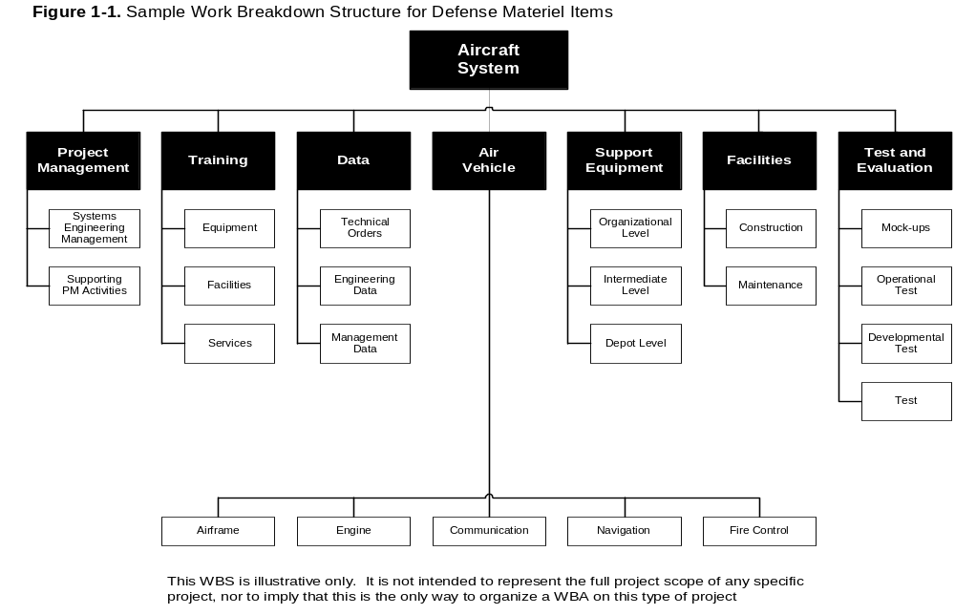
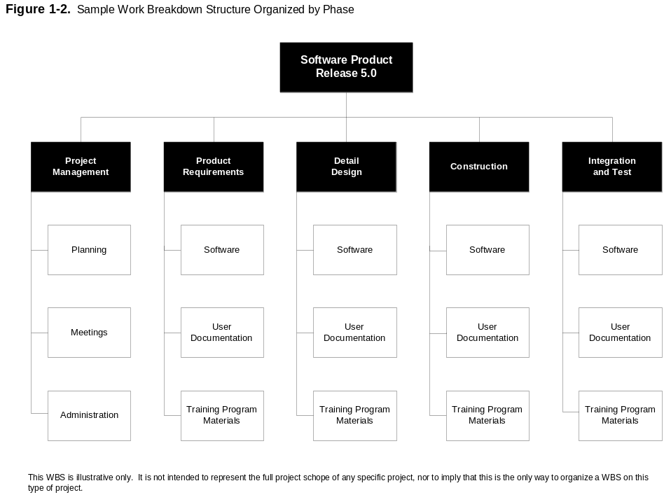

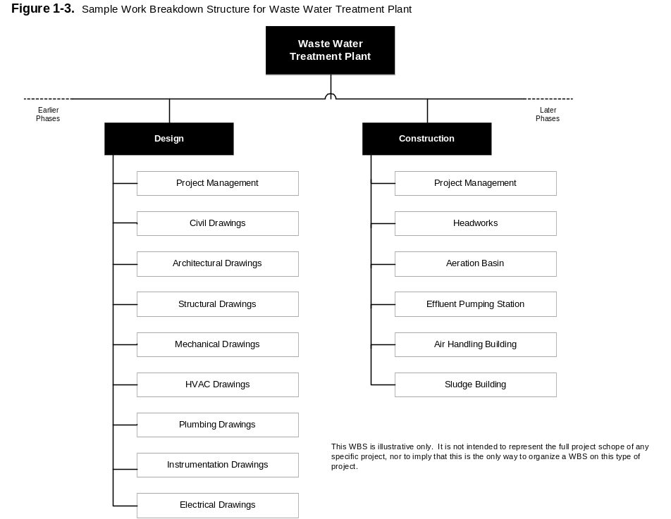

© 1996 Project Management Institute, 130 South State Road, Upper Darby, PA 19082 USA
"Project Scope Management." A Guide to the Project Management Body of Knowledge. pp. 54-55.

ACME Intranet WBS:
(Use the space provided to layout your work breakdown structure for the project.)

ACME WBS (Possible Solution)

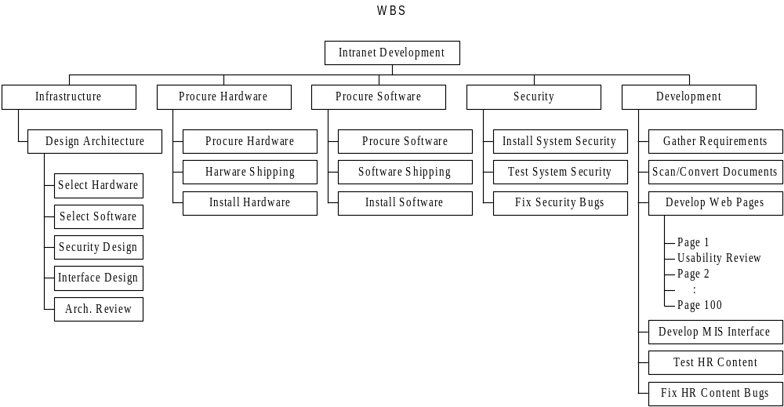

Network Diagram
Draw or create a network diagram of the project using the following identified tasks. It is usually easy to create the network diagram by using large yellow post-it notes for each task. Identify the task id, task name, predecessor and successor task id's, and task durations on each post-it. Arrange the notes in the proper order and draw the logic ties between tasks.

ID | Task Name | Duration | Predecessors | Successors
A | Design Architecture | 9d
B | Architecture Review | 1d
C | Procure Hardware | 0d
D | Hardware Shipping | 10d
E | Install Hardware | 5d
F | Procure Software | 0d
G | Software Shipping | 5d
H | Install Software | 5d
I | Gather HR Requirements | 5d
J | Scan/Convert Documents | 15d
K | Develop HR Web Pages | 15d
L | Develop HR MIS Interface | 10d
M | Test HR | 10d
N | Fix HR Intranet Bugs | 5d
O | Install System Security | 5d
P | Test Security | 5d
Q | Fix Security Bugs | 5d
R | Buffer | 10d
S | Go Live | 0d

The following logic tie information is known: (All relationships are Finish-to-Start)

The architecture must be finished before the hardware or software may be ordered. Once the hardware is installed then the software and security system can be installed. The MIS interface cannot be developed until the software is up and running. Web page development can begin as soon as all the underlying documents are scanned and ready in digital form. HR requirements must be gathered to determine which documents should be scanned.

The system security can be tested following security installation. Security fixes should be made following the security test. The new HR system can be tested following development of the Web pages and the MIS interface. HR intranet bug fixes can be made following this testing. The system should then be able to go live once all bug fixes are completed. A buffer task (which usually comes from the risk management plan) is suggested to help account for unforeseen delays in the work to be completed. A good rule of thumb for small projects is to add 10% to the duration. This buffer task is added prior to the "Go Live" milestone for planning purposes.

Draw the Network Diagram and determine the Predecessor and Successor tasks using the information given.

Network Diagram (Solution)

Q
P
O
S
R

L
M
N
B

K
A
C
I
G
J
H
D
E
F

Predecessor and Successor (Solution)

ID | Task Name | Duration | Predecessors | Successors
A | Design Architecture | 9d |  | B
B | Architecture Review | 1d | A | C, F, L
C | Order Hardware | 0d | B | D
D | Hardware Shipping | 10d | C | E
E | Install Hardware | 5d | D | H, O
F | Order Software | 0d | B | G
G | Software Shipping | 5d | F | H
H | Install Software | 5d | E, G | L
I | Gather HR Requirements | 5d |  | J
J | Scan/Convert Documents | 15d | I | K
K | Develop HR Web Pages | 15d | J | M
L | Develop HR MIS Interface | 10d | B, H | M
M | Test HR | 10d | K, L | N
N | Fix HR Intranet Bugs | 5d | M | R
O | Install System Security | 5d | E | P
P | Test Security | 5d | O | Q
Q | Fix Security Bugs | 5d | P | R
R | Buffer | 10d | N, Q | S
S | Go Live | 0d | R

Critical Path

Determine the critical path through the network diagram.

Calculate the duration of the entire project with and without the buffer.

Critical Path (Solution)

Trace each path through the diagram and sum the individual task durations in order to determine the path totals. The critical path has the longest total duration path through the network diagram. It is possible to have multiple critical paths within a project.

Determine the critical path through the network diagram.

A
C
I
G
J
K
H
L
M
Q
D
E
F
P
N
O
S
R
B

The critical path is: A-B-C-D-E-H-L-M-N-R-S

Calculate the duration of the entire project with and without the buffer.

Duration with the buffer task Q is: 65 days.

Duration without buffer task Q is: 55 days.

Gantt Chart

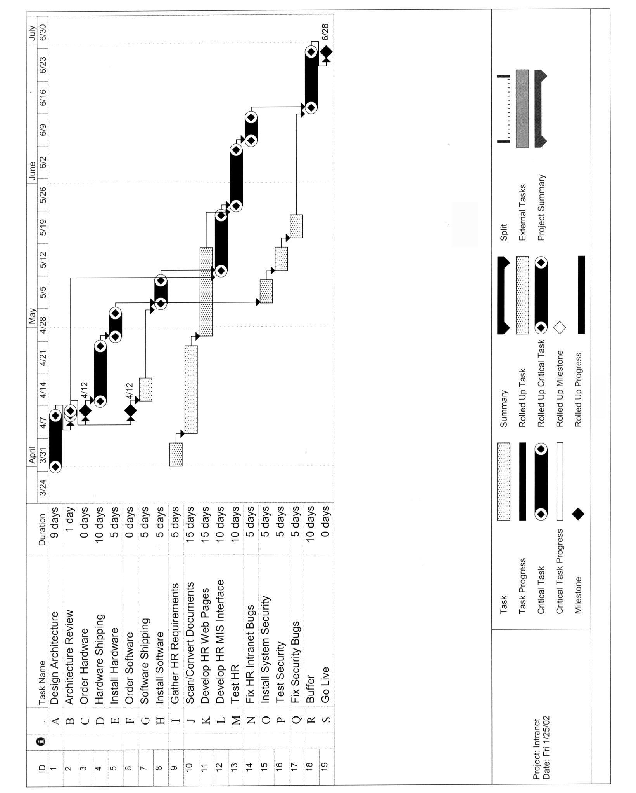

Project Execution Exercise

Win All That You Can!

Rules:

- Break up into 4 teams of 4 players per group.
- Each team is given two cards, a red one and a green one.
- Each team will hold their cards face down so that the other teams can't see the cards.
- On the signal from the instructor each team should immediately turn up just one card.
- Each team should record their scores from the table below.

Combination | Green Score | Red Score
All Teams Select Green Cards | Win $10
One Team Selects Red | Lose $10 | Win $30
Two Teams Select Red | Lose $20 | Win $20
Three Teams Select Red | Lose $30 | Win $10
All Teams Select Red Cards |  | Lose $10

- The object of the game is to "Win All That You Can".
- A total of 10 rounds will be played to determine the ultimate winner.
- Record and tally your scores below.

Round | Score
Round 1
Round 2
Round 3
Round 4
Round 5
Round 6
Round 7
Round 8
Round 9
Round 10
Total:

Project Control Exercise

Managing the Project

During execution of the project plan you discover that a key member of the architecture team will be unavailable for the first week of the project due to a family crisis. You would like to minimize the impact of this unforeseen event on the project. What are some possible solutions?

It might be helpful to review the Gantt chart for the project to determine possible solutions. Also see whether the task in question is on the critical path.

Fill out the table below with some of your ideas, along with the pros and cons of each idea.

Solution | Pros | Cons

Managing the Project (Possible Solutions)

During execution of the project plan you discover that a key member of the architecture team will be unavailable for the first week of the project due to a family crisis. You would like to minimize the impact of this unforeseen event on the project. What are some possible solutions?

It might be helpful to review the Gantt chart for the project to determine possible solutions. Also see whether the task in question is on the critical path.

Design Architecture is on the critical path.

Fill out the table below with some of your ideas, along with the pros and cons of each idea.

Solution | Pros | Cons
Don’t do anything because there is enough buffer in the project to cover the absence for 1 week. | Simple | Increases the risk of missing the deadline and reduces half of your buffer at the outset of the project.
Reduce the shipping time to try to offset the architecture delay. | Reduces the critical path for the project without adding any work. | May be more expensive or may not be possible.
Reduce the critical path by doing the hardware and software installation in parallel (Crashing). | Shortens the schedule | Increases risk. Hardware and software installation tasks are likely to take more time.
Find a replacement for the missing resource. | Avoids the delay in starting the architecture design task. | May reduce the quality of the system design. May interfere with other projects in the organization.
Have the architecture team put in lots of overtime when the missing resource returns. | Could avoid part or all of the delay in finishing the architecture task. May discover that the task was padded. | May reduce the quality of the design and burn out the project team.
Find a replacement for the missing resource and have this person do as much as possible. Finish the task once the key resource returns | Minimizes task slippage while still taking advantage of the key resource's expertise. | May reduce quality.

